# **Notice of unknown service line material**

### **Brewster Utilities** is focused on protecting the health of every household in our community. This notice contains important information about your drinking water. Please share this information with anyone who drinks and/or cooks using water at this property. In addition to people directly served at this property, this can include people in apartments, nursing homes, schools, businesses, as well as parents served by childcare at this property.

### **Brewster Utilities** is working to identify service line materials throughout the water system and has determined that the water pipe (called a service line) that connects your **Home** to the water main is made from **unknown material** but may be lead. Because your service line material is unknown, there is the potential that some or all of the service line could be made of lead or galvanized pipe that was previously connected to lead. People living in homes with a lead or galvanized pipe previously connected to a lead service line have an increased risk of exposure to lead from their drinking water.

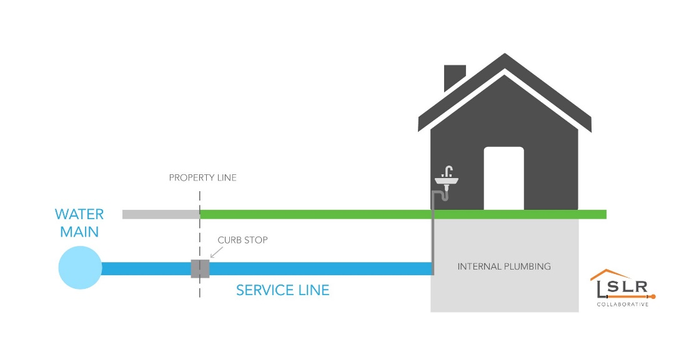

## Identifying service line material

To help determine the material of your service line, please contact your housing management office or Utility provider **U.S. Water Corporation @ uswatercorp.com or call (727) 848-8292 .** EPA has developed an online step-by-step guide to help people identify lead pipes in their homes called Protect Your Tap: A Quick Check for Lead. It is available at: <https://www.epa.gov/ground-water-and-drinking-water/protect-your-tap-quick-check-lead>.

## Health effects of lead

*Exposure to lead in drinking water can cause serious health effects in all age groups. Infants and children can have decreases in IQ and attention span. Lead exposure can lead to new learning and behavior problems or worsen existing learning and behavior problems. The children of women who are exposed to*

*lead before or during pregnancy can have increased risk of these negative health effects. Adults can have increased risks of heart disease, high blood pressure, and kidney, or nervous system problems.[1]*

## Steps you can take to reduce lead in drinking water.

Below are recommended actions that you may take, separately or in combination, if you are concerned about lead in your drinking water. The list also includes where you may find more information and is not intended to be a complete list or to imply that all actions equally reduce lead in drinking water.

**Use filters properly**. Using a filter can reduce lead in drinking water. If you use a filter, it should be certified to remove lead. Read any directions provided with the filter to learn how to properly install, maintain, and use your cartridge and when to replace it. Using the cartridge after it has expired can make it less effective at removing lead. Do not run hot water through the filter. For more information on facts and advice on home water filtration systems, see EPA’s <https://www.epa.gov/water-research/consumer-tool-identifying-point-use-and-pitcher-filters-certified-reduce-lead>.

**Clean your aerator.** Regularly clean your faucet’s screen (also known as an aerator). Sediment, debris, and lead particles can collect in your aerator. If lead particles are caught in the aerator, lead can get into your water.

**Use cold water**. Do not use hot water from the tap for drinking, cooking, or making baby formula as lead dissolves more easily into hot water. Boiling water does not remove lead from water.

**Run your water.** The more time water has been sitting in pipes providing water to your home, the more lead it may contain. Before drinking, flush your home’s pipes by running the tap, taking a shower, doing laundry, or doing a load of dishes. The amount of time to run the water will depend on whether your home has a lead service line or not, as well as the length and diameter of the service line and the amount of plumbing in your home. [Include tailored flushing information, if appropriate, or add following language] Residents may contact us at [phone number and/or email address] for recommendations about flushing times in their community.

**Learn what your service line material is.** Contact us at USwatercorp.com or call (727) 848-8292 or a licensed plumber to determine if the pipe that connects your home to the water main (called a service line) is made from lead, galvanized, or other materials. [For systems replacing lead service lines consider the following text.] To find out about what we are doing to replace lead service lines, please visit uswatercorp.com or contact us at (727) 848-8292. [Protect Your Tap: A quick check for lead](https://www.epa.gov/ground-water-and-drinking-water/protect-your-tap-quick-check-lead-0) is EPA’s on-line step by step guide to learn how to find lead pipes in your home.

**Learn about construction in your neighborhood.** Contact us at uswatercorp.com or call (727) 848-8292 to find out about any construction or maintenance work that could disturb your service line. Construction may cause more lead to be released from a lead service line or galvanized service line if present.

**Have your water tested.** Contact us, your water utility, at **U.S. Water Corporation @ uswatercorp.com or call (727) 848-8292** to have your water tested and to learn more about the lead levels in your drinking water. Alternatively, you may contact a certified laboratory to have your water tested for lead. A list of certified laboratories is available at **Florida Department of Health.** Note, a water sample may not adequately capture or represent all sources of lead that may be present**.** For information on sources of lead that include service lines and interior plumbing, please visit <https://www.epa.gov/ground-water-and-drinking-water/basic-information-about-lead-drinking-water#getinto>.

## Get your child tested to determine lead levels in their blood.

Although there is no confirmation of having a lead service line, you may wish to speak with a healthcare provider to see if your child’s blood lead level is elevated and/or if there is a need for blood testing, if you are concerned about potential exposure. Please visit <https://www.cdc.gov/nceh/lead/advisory/acclpp/actions-blls.htm> for information on these actions.

**For information about potential financing solutions** to assist property owners with replacement of lead service lines, please contact us at **FRWA Florida Rural Water Association.com or call (850) 668-2746**

**For more information on reducing lead exposure** from your drinking water and the health effects of lead, visit EPA’s website at [[*http://www.epa.gov/lead*](http://www.epa.gov/lead)](http://www.epa.gov/lead).

1. Text in italics is required and cannot be changed.